RK Health DashBoard

Introduction:
RK Health is a modern healthcare management application designed to simplify the process of managing patient appointments, medication schedules, health records, and healthcare reminders. Developed to meet the needs of patients, caregivers, and healthcare providers, RK Health provides a convenient platform where users can organize medical information, schedule appointments, receive medication reminders, and access AI-generated health summaries efficiently. With its user-friendly interface and secure management system, RK Health ensures a seamless healthcare experience, allowing users to stay informed about their health with ease. Whether managing appointments, tracking medications, or maintaining health records, RK Health serves as a reliable solution for modern healthcare management.
Healthcare management refers to the process of organizing, tracking, and maintaining patient-related healthcare information through digital platforms. It has become an essential part of modern healthcare systems, offering convenience, accessibility, and efficiency to both patients and healthcare providers. With advancements in web technologies, healthcare services have evolved from paper-based records and manual tracking methods to intelligent cloud-based applications and digital healthcare platforms.
The convenience of managing healthcare activities online has transformed the way users interact with medical services. RK Health enables users to schedule appointments, manage medication reminders, store health records, generate AI-powered visit summaries, and access detailed health reports. The platform provides a smooth and efficient experience, allowing users to monitor and manage their healthcare activities from anywhere and at any time.

Scenario Based Case Study:
- Ravi is a busy professional who regularly manages doctor appointments, medication schedules, and health records for himself and his family. Keeping track of appointment dates, remembering medication timings, and maintaining medical records has become a challenging task. He often misses follow-up appointments, forgets medication schedules, and struggles to organize healthcare information efficiently. Similarly, healthcare providers and caregivers face difficulties in ensuring timely communication and patient compliance. To address these challenges, RK Health provides a centralized platform that simplifies healthcare management for patients, caregivers, and healthcare professionals.
- User Registration and Authentication: Enable users to register accounts, log in securely, and authenticate their identity to access the RK Health platform.
- Appointment Management: Allow users to create, update, view, and manage doctor appointments with details such as doctor name, appointment date, time, location, and visit notes.
- Medication Reminder Management: Provide functionality for users to add medication schedules, dosage information, timing details, and receive timely reminder notifications.
- Health Records and Reports: Allow users to maintain centralized health records, view appointment history, medication logs, AI-generated health summaries, and generate comprehensive health reports.
- AI Health Summary Generation: Enable users to generate patient-friendly summaries from appointment notes and visit information using AI, helping them better understand diagnoses, recommendations, and follow-up actions.

SYSTEM REQUIREMENTS :
To ensure smooth development, deployment, and usage of the RK Health – AI Smart Patient Appointment & Medication Reminder System, certain system prerequisites must be met. These requirements are categorized into software, setup, and hardware specifications, all of which contribute to building a reliable and scalable healthcare management platform.

1. Software Requirements
These are the essential tools and platforms required to develop, test, and run the application efficiently.
- Operating System: Windows 10/11, macOS, or Linux — Supports cross-platform development and testing.
- Web Browser: Google Chrome, Mozilla Firefox, Microsoft Edge (latest versions) — For accessing and testing the application.
- Google Apps Script: Used for backend development, API handling, and cloud service integration.
- Google Sheets: Acts as the cloud database for storing patient records, appointments, medication schedules, reports, and AI summaries.
- Google Calendar: Used for appointment scheduling and reminder management.
- Twilio SMS API: Enables automated medication and appointment reminder notifications.
- Groq API (Llama 3.3 70B Versatile): Used for generating AI-powered health summaries and recommendations.
- Visual Studio Code: Preferred code editor for frontend development and project management.
- Git & GitHub: Used for version control, collaboration, and frontend deployment through GitHub Pages.
- Postman: Used for testing APIs and validating backend responses.

2. Hardware Requirements
Describes the minimum and recommended specifications needed to support the development and usage of the application.
- Processor: Intel Core i5 (8th Generation or above) / AMD Ryzen 5 or equivalent.
- RAM: Minimum 8 GB (16 GB recommended) for efficient multitasking and browser operations.
- Storage: Minimum 2 GB free space for project files, development tools, and configuration resources.
- Display: 1366 × 768 resolution or higher for optimal dashboard visualization and development experience.
- Internet Connection: Stable broadband connection required for accessing cloud services, AI APIs, Google services, and SMS integrations.

PROJECT ARCHITECTURE

Technical Architecture:

Technical Architecture
In this technical architecture, the RK Health – AI Smart Patient Appointment & Medication Reminder System consists of several components:
User Interface: Represents the web dashboard through which patients, caregivers, and healthcare providers interact with the system to manage appointments, medication schedules, health records, reminders, reports, and AI-generated summaries.
Web Server: Hosts the frontend application and serves web pages to users, ensuring smooth communication between the user interface and backend services.
Google Apps Script Backend: Acts as the central processing layer that handles requests, performs validation, executes business logic, manages records, and coordinates interactions with external services.
Google Sheets Database: Stores persistent healthcare data including patient records, appointments, medication schedules, AI summaries, reports, reminder logs, and dashboard statistics.
Appointment Management Service: Handles appointment creation, modification, deletion, scheduling, and retrieval while integrating with Google Calendar.
Medication Reminder Service: Manages medication schedules, dosage information, reminder timings, and notification tracking.
AI Summary Service: Processes appointment notes and health records, communicates with the Groq API, and generates patient-friendly health summaries.
SMS Notification Service: Integrates with Twilio to send appointment reminders, medication alerts, and notification updates to patients.
Google Calendar Service: Creates calendar events and generates appointment reminder schedules for users.
Report Management Service: Generates healthcare reports containing appointment history, medication records, compliance status, and AI-generated summaries.

ER Diagram

Patient
- PatientID (PK)
- PatientName
- PhoneNumber
- Email
- DateOfBirth
- Gender
- Address
- CreatedAt

Appointment
- AppointmentID (PK)
- PatientID (FK)
- DoctorName
- AppointmentTitle
- HospitalName
- AppointmentDate
- AppointmentTime
- VisitNotes
- Status
- CreatedAt

Medication
- MedicationID (PK)
- PatientID (FK)
- MedicineName
- Dosage
- Frequency
- Timing
- StartDate
- EndDate
- Instructions
- ReminderStatus

Summary
- SummaryID (PK)
- PatientID (FK)
- AppointmentID (FK)
- AISummary
- GeneratedDate

Report
- ReportID (PK)
- PatientID (FK)
- SummaryID (FK)
- ReportData
- CreatedDate

ReminderLog
- ReminderID (PK)
- PatientID (FK)
- MedicationID (FK)
- Message
- DeliveryStatus
- Timestamp

Relationships Between Entities

Patient – Appointment Relationship
One-to-Many relationship between Patient and Appointment.
- One patient can have multiple appointments.
- Foreign Key: PatientID in Appointment.

Patient – Medication Relationship
One-to-Many relationship between Patient and Medication.
- One patient can have multiple medication schedules.
- Foreign Key: PatientID in Medication.

Appointment – Summary Relationship
One-to-One relationship between Appointment and Summary.
- One appointment can generate one AI summary.
- Foreign Key: AppointmentID in Summary.

Patient – Summary Relationship
One-to-Many relationship between Patient and Summary.
- One patient can have multiple AI-generated summaries.
- Foreign Key: PatientID in Summary.

Patient – Report Relationship
One-to-Many relationship between Patient and Report.
- One patient can have multiple healthcare reports.
- Foreign Key: PatientID in Report.

Summary – Report Relationship
One-to-Many relationship between Summary and Report.
- Reports may contain one or more AI-generated summaries.
- Foreign Key: SummaryID in Report.

Medication – ReminderLog Relationship
One-to-Many relationship between Medication and ReminderLog.
- One medication schedule can generate multiple reminders.
- Foreign Key: MedicationID in ReminderLog.

Patient – ReminderLog Relationship
One-to-Many relationship between Patient and ReminderLog.
- One patient can receive multiple reminder notifications.
- Foreign Key: PatientID in ReminderLog.

Key Features
- User Registration and Authentication: Enable patients and healthcare users to register accounts, log in securely, and authenticate their identity to access the RK Health platform.
- Appointment Management: Allow users to create, update, delete, and manage doctor appointments with details such as doctor name, appointment date, time, location, and visit notes.
- Medication Reminder Management: Provide functionality to schedule medications, record dosage information, set reminder timings, and manage medication adherence effectively.
- AI Health Summary Generation: Generate patient-friendly healthcare summaries from appointment notes, visit details, and medical information using the Groq AI model.
- Health Records Management: Maintain centralized healthcare records including appointments, medications, summaries, reports, and reminder history for easy access and tracking.
- Appointment Details View: Allow users to view complete appointment information, including doctor details, visit notes, appointment schedules, and follow-up recommendations.
- SMS Reminder Notifications: Send automated appointment and medication reminders through Twilio SMS integration to improve compliance and reduce missed schedules.
- Google Calendar Integration: Enable users to add appointments directly to Google Calendar and receive calendar-based reminders for upcoming visits.
- Health Report Generation: Generate comprehensive healthcare reports containing appointment history, medication records, AI summaries, reminder status, and health insights.
- Dashboard Analytics: Display healthcare statistics such as total appointments, active medications, completed reminders, generated summaries, and recent healthcare activities.
- Reminder History Tracking: Maintain records of all sent reminders, delivery status, and notification history for monitoring and auditing purposes.
- Responsive Dashboard Interface: Provide a modern and user-friendly dashboard that works seamlessly across desktop, tablet, and mobile devices.
- Cloud-Based Data Storage: Utilize Google Sheets as a cloud database to securely store and manage healthcare records, reports, summaries, and reminder logs.
- Data Validation and Security: Implement input validation, secure data handling, and proper access controls to ensure the integrity and reliability of healthcare information.
- REST API Integration: Utilize Google Apps Script APIs and external service integrations for seamless communication between the frontend, cloud database, AI services, SMS notifications, and calendar services.
- These are some of the major features of RK Health, and additional functionalities can be incorporated based on future requirements and the evolving needs of healthcare management systems.

Roles and Responsibility

Roles and Responsibilities

User (Patient)
Registration and Login: Patients can create an account, log in securely, and manage their profile information.
Appointment Management: Patients can schedule doctor appointments, view appointment details, update appointments, and track upcoming visits.
Medication Management: Patients can add medication schedules, dosage details, reminder timings, and monitor medication adherence.
Health Summary and Reports: Patients can generate AI-powered health summaries, view health records, and access comprehensive health reports.
Reminder Tracking: Patients can receive SMS reminders for appointments and medications and track reminder history.
Logout: Patients can securely log out from the RK Health platform.

Healthcare Provider / Caregiver
Patient Record Management: Healthcare providers can review patient information, appointment history, and health records.
Appointment Monitoring: Providers can manage appointment schedules and update visit notes when required.
Health Information Support: Providers can assist patients by reviewing generated summaries and healthcare reports.
Logout: Healthcare providers can securely log out from the RK Health platform.

Administrator
Patient Management: Administrators can manage patient records, monitor healthcare activities, and maintain system data.
Appointment and Medication Monitoring: Administrators can oversee appointments, medication schedules, reminder statuses, and overall healthcare operations.
System Monitoring: Administrators can generate reports, view dashboard analytics, monitor integrations, and ensure smooth platform functionality.
Service Management: Administrators can monitor Google Sheets storage, Twilio SMS services, Google Calendar integration, and AI summary generation services.
Logout: Administrators can securely log out from the RK Health platform.

User Flow

Start
The process begins when users access the RK Health application.

Home Dashboard
Users land on the dashboard, which displays healthcare statistics, upcoming appointments, medication reminders, recent activities, and available healthcare services.

User Registration/Login
Users can register a new account or log in securely to access personalized healthcare management features.

Appointment Management
Users can create and manage doctor appointments by entering appointment details such as doctor name, date, time, and visit notes.

Medication Management
Users can add medication schedules, dosage information, reminder timings, and instructions for proper medication tracking.

Generate AI Health Summary
After an appointment, users can generate an AI-powered health summary based on visit notes, appointment details, and healthcare information.

View Health Records and Reports
Users can view appointment history, medication records, reminder logs, AI-generated summaries, and detailed health reports.

Receive Reminders
The system automatically sends SMS reminders for upcoming appointments and medication schedules through Twilio integration.

Google Calendar Scheduling
Users can add appointments directly to Google Calendar and receive calendar-based notifications.

Dashboard Monitoring
Users can monitor healthcare activities, reminder status, compliance information, and recent healthcare updates through the dashboard.

End
The flow concludes after users complete their desired activities, such as scheduling appointments, managing medications, generating summaries, viewing reports, or tracking reminders.
This flow outlines the user journey within the RK Health application, starting from login and healthcare management to AI-assisted summaries, reminder notifications, and health report generation. It ensures a smooth, organized, and user-friendly healthcare management experience for patients, caregivers, and administrators.

MVC Pattern :
The RK Health – AI Smart Patient Appointment & Medication Reminder System follows the Model-View-Controller (MVC) architectural pattern, a software design approach that separates the application into three interconnected layers. This separation improves maintainability, scalability, and overall system organization.

Model Layer (Data Layer)
The Model layer is responsible for handling all healthcare-related data and storage operations. In RK Health, Google Sheets acts as the cloud database, storing and managing patient records, appointments, medication schedules, AI-generated summaries, reports, and reminder logs.
The primary data models used in RK Health include Patient, Appointment, Medication, Summary, Report, and ReminderLog. These models manage healthcare information and ensure structured data storage and retrieval throughout the system.

Controller Layer
The Controller layer is implemented through Google Apps Script backend functions. It acts as an intermediary between the frontend dashboard and the data storage layer. The controller receives requests from users, validates input data, processes healthcare operations, communicates with external services, and returns structured responses.
The main controller functions include:
- doGet(e)
- addLog()
- getLogs()
- updateLog()
- deleteLog()
- getStats()
- generateSummary()
- sendSMS()
- runOnce()
These functions handle appointment management, medication tracking, AI summary generation, SMS reminders, dashboard statistics, report generation, and cloud storage operations.

View Layer (Presentation Layer)
The View layer represents the frontend user interface developed using HTML, CSS, and JavaScript. It provides an interactive healthcare dashboard where users can manage appointments, medications, reminders, health reports, and AI-generated summaries.
The frontend includes:
- Dashboard Overview
- Appointment Management Section
- Medication Reminder Section
- AI Summary Viewer
- Health Report Section
- Notification System
- Responsive Navigation Components
The View layer communicates with the Google Apps Script backend through asynchronous API requests and dynamically updates the interface based on received data.

Advantages of Using MVC in RK Health
Separation of Concerns: Each layer has a clearly defined responsibility, improving code organization and maintainability.
Scalability: New healthcare features and integrations can be added easily without affecting existing functionality.
Reusability: Backend functions and data processing logic can be reused across multiple modules.
Testing and Debugging: Individual layers can be tested independently, making issue identification and resolution easier.
Maintainability: Updates to the user interface, backend processing, or data storage can be performed without impacting other layers.
Integration-Friendly: The architecture simplifies integration with external services such as Groq AI, Twilio SMS, Google Sheets, and Google Calendar.
By adopting the MVC architecture, RK Health achieves a modular, scalable, and efficient healthcare management system capable of supporting future enhancements and growing user requirements.

PROJECT SETUP AND CONFIGURATION :

PROJECT SETUP AND CONFIGURATION

Creating Project Folder
- Create a new folder named RK-Health.
- Open the folder in Visual Studio Code.
- Inside the folder, create the following files:
- RK-Health/

- ├── index.html
- ├── style.css
- ├── script.js
- ├── config.js
- ├── README.md
- │
- ├── assets/
- │ ├── images/
- │ └── icons/
- │
- ├── backend/
- │ ├── Code.gs
- │ ├── AI.gs
- │ ├── Sheets.gs
- │ ├── Twilio.gs
- │ └── Utils.gs
- │
- └── docs/
- ├── architecture.md
- ├── api-documentation.md
- ├── database-schema.md
- └── deployment-guide.md

Frontend Setup

Create Frontend Files
Inside the RK-Health folder create:
- index.html
- style.css
- script.js
- config.js

Configure Frontend
Add the required CDN resources:
- Google Fonts (Poppins)
- Font Awesome Icons
Configure:
- const SCRIPT_URL = "YOUR_GOOGLE_APPS_SCRIPT_WEBAPP_URL";

inside config.js.

Run Frontend
Since the frontend is built using HTML, CSS, and JavaScript:
- Open index.html directly in a browser
OR
Use VS Code Live Server:
- Install Live Server Extension
- Right Click → Open with Live Server

Backend Setup (Google Apps Script)

Create Google Apps Script Project
- Open Google Apps Script.
- Click New Project.
- Rename project as:
- RK Health Backend

Create Script Files
Create the following files:
- Code.gs
- AI.gs
- Sheets.gs
- Twilio.gs
- Utils.gs

Google Sheets Database Setup

Create Spreadsheet
Create a spreadsheet named:
- RK Health Database

Create Sheets:
- Appointments
- Medications
- Summaries
- Reports
- ReminderLogs

Configure Columns

Appointments
- AppointmentID
- PatientName
- DoctorName
- Title
- Hospital
- Date
- Time
- Phone
- Notes
- CreatedAt

Medications
- MedicationID
- PatientName
- MedicineName
- Dosage
- Frequency
- Timing
- StartDate
- EndDate
- Phone
- Instructions
- Status
- CreatedAt

Summaries
- SummaryID
- PatientName
- Summary
- GeneratedDate

Reports
- ReportID
- PatientName
- ReportData
- CreatedDate

ReminderLogs
- ReminderID
- PatientName
- Message
- Status
- Timestamp

Twilio Configuration
Create a Twilio account and obtain:
- Account SID
- Auth Token
- Twilio Phone Number

Store them securely inside Apps Script Properties:
- TWILIO_ACCOUNT_SID
- TWILIO_AUTH_TOKEN
- TWILIO_PHONE_NUMBER

Groq AI Configuration

Create Groq Account
Visit:
- https://console.groq.com

Generate API Key
- Open API Keys.
- Create API Key.
- Copy the generated key.

Store in Apps Script Properties
- GROQ_API_KEY

AI Model Configuration
Model:
- llama-3.3-70b-versatile
- Temperature: 0.8
- Max Tokens: 2048

Google Calendar Configuration
Enable:
- Google Calendar API

Used for:
- Appointment Scheduling
- Reminder Creation
- Calendar Event Links

Deploy Backend

Deploy Google Apps Script
- Click Deploy
- Select New Deployment
- Choose Web App
Configuration:
Execute As:
- Me
- Who Has Access:
- Anyone

- Deploy.
- Copy generated Web App URL.

Connect Frontend and Backend
Inside config.js
- const SCRIPT_URL = "YOUR_GOOGLE_APPS_SCRIPT_WEBAPP_URL";
BACKEND DEVELOPMENT:
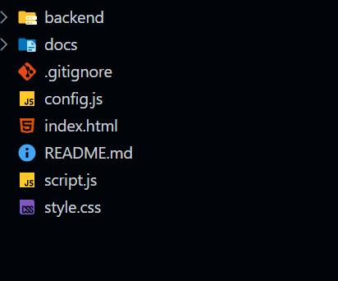

Backend Development

Setup Google Apps Script Backend
Create a Google Apps Script project to serve as the backend for the RK Health application.
Create the following files:
Code.gs
AI.gs
Sheets.gs
Twilio.gs
Utils.gs

Configure Script Properties to securely store:
- GROQ_API_KEY
- TWILIO_ACCOUNT_SID
- TWILIO_AUTH_TOKEN
- TWILIO_PHONE_NUMBER
- SPREADSHEET_ID
Configure the backend by integrating Google Sheets, Twilio SMS services, Groq AI services, and Google Calendar functionality.

Healthcare Record Management
Create backend functions for appointment management, medication tracking, health reports, AI summaries, and reminder services.
Set up backend processing functions to handle healthcare operations and cloud database interactions.

Define Backend Functions
Create separate functions for different healthcare functionalities.
Functions include:
- doGet(e)
- addLog()
- getLogs()
- updateLog()
- deleteLog()
- getStats()
- generateSummary()
- sendSMS()
- runOnce()
Implement backend processing logic using Google Apps Script to handle requests and communicate with cloud services.

Implement Data Management
Define healthcare data structures for different entities such as patients, appointments, medications, summaries, reports, and reminder logs.
Create corresponding storage operations to interact with Google Sheets.
Implement CRUD operations (Create, Read, Update, Delete) for each healthcare module to perform cloud database operations.

Input Validation and Processing
Create validation functions to verify healthcare information before processing.
Validate:
- Patient information
- Appointment details
- Medication schedules
- Phone numbers
- Visit notes
Process submitted information and store validated records into Google Sheets.

AI Summary Integration
Configure Groq AI integration for health summary generation.
Generate patient-friendly summaries using:
- Appointment records
- Visit notes
- Medication details
- Follow-up recommendations
Store generated summaries in the cloud database and return results to the dashboard.

SMS Reminder Services
Configure Twilio SMS integration to send:
- Medication reminders
- Appointment reminders
- Healthcare notifications
Track SMS delivery status and maintain reminder history records.

Error Handling
• Implement error handling functions to catch and handle errors during healthcare operations.
• Return appropriate error responses with meaningful messages and operation status information.

Database Development

1. Configure Google Sheets Database
Create a Google Sheets database.
Create worksheets for:
- Appointments
- Medications
- Summaries
- Reports
- Reminder Logs
Configure the spreadsheet to act as the primary cloud storage solution for RK Health.

2. Connect Database to Backend
Now, make sure the Google Sheets database is connected before performing any healthcare operations through the backend.
The connection logic should establish communication between Google Apps Script and Google Sheets to support record storage, retrieval, updates, and reporting.

3. Configure Data Structure
Firstly, configure the data structures for Google Sheets to store healthcare information in a structured format.
Use the ER diagram entities to create data storage layouts.
The data structures include:
- Patient Records
- Appointment Records
- Medication Records
- AI Summaries
- Reports
- Reminder Logs

Front-End Development

1. Setup Frontend Application
• Create frontend application using HTML, CSS, and JavaScript.
• Configure dashboard navigation.
• Integrate required external libraries and resources.

2. Design UI Components
• Create dashboard components.
• Implement responsive layout and styling.
• Add navigation menus and healthcare modules.

3. Implement Frontend Logic
• Integrate frontend with Google Apps Script API endpoints.
• Implement dynamic data rendering and dashboard updates.
• Handle form submissions and user interactions.

Frontend Modules
Create separate interface sections for:
- Dashboard Overview
- Appointment Management
- Medication Management
- AI Summary Generation
- Health Report Generation
- Reminder Tracking
- Notifications

Dashboard Integration
Implement communication between frontend and backend services.
The frontend should:
- Submit healthcare records
- Retrieve stored data
- Display reports
- Show dashboard statistics
- Render AI summaries
- Track reminder status

User Experience Features
Implement:
- Loading indicators
- Toast notifications
- Modal dialogs
- Search functionality
- Filter controls
- Responsive design

Data Binding
Ensure all dashboard components update dynamically based on backend responses.
The application should display updated information without requiring manual page refreshes, providing a smooth and efficient healthcare management experience.

Project Execution

- Steps for Project execution
Step 1: Set Up the Frontend

a) Open the project folder and navigate to the frontend files.

Open the RK Health project folder in Visual Studio Code.

b) Start the frontend application.

If using the Live Server extension, right-click on index.html and select:

Open with Live Server

c) The application should now be running on:

http://localhost:5500

Step 2: Set Up the Backend (Google Apps Script)

a) Open Google Apps Script in your browser.

b) Open the RK Health backend project created earlier.

c) Ensure all backend files are available:

Code.gs
AI.gs
Sheets.gs
Twilio.gs
Utils.gs

Step 3: Configure Environment Variables

Inside the Google Apps Script project, open:

Project Settings → Script Properties

Add the required configuration values:

GROQ_API_KEY=your_groq_api_key

TWILIO_ACCOUNT_SID=your_account_sid

TWILIO_AUTH_TOKEN=your_auth_token

TWILIO_PHONE_NUMBER=your_twilio_phone_number

SPREADSHEET_ID=your_google_sheet_id

Step 4: Deploy the Backend Server

Inside the Google Apps Script project:

Deploy → New Deployment → Web App

Configure:

Execute As: Me

Who Has Access: Anyone

Click Deploy and copy the generated Web App URL.

The backend should be accessible through:

https://script.google.com/macros/s/your_deployment_id/exec

Step 5: Connect Frontend and Backend

Open config.js

Save the file.

Step 6: Start Using the Application

Open the frontend application in the browser and verify:

• Appointment Management
• Medication Reminder Management
• AI Health Summary Generation
• SMS Reminder Notifications
• Health Report Generation
• Dashboard Statistics

Verify that:

• Records are stored in Google Sheets
• AI summaries are generated successfully
• SMS reminders are delivered through Twilio
• Dashboard data updates correctly
• Reports are generated and displayed properly

The RK Health application should now be running successfully with the frontend connected to the Google Apps Script backend, Google Sheets database, Groq AI services, Twilio SMS notifications, and Google Calendar integration.

OUTPUT SCREENSHOTS:
Finally, after finishing coding the projects we run the whole project to test it’s working process and look for bugs. Now, let’s have a final look at the working of our Darshan Ease.

Landing page:-
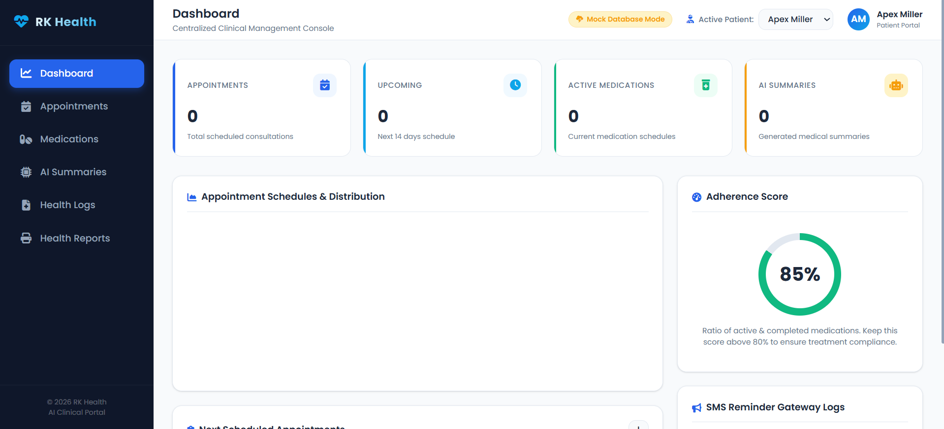

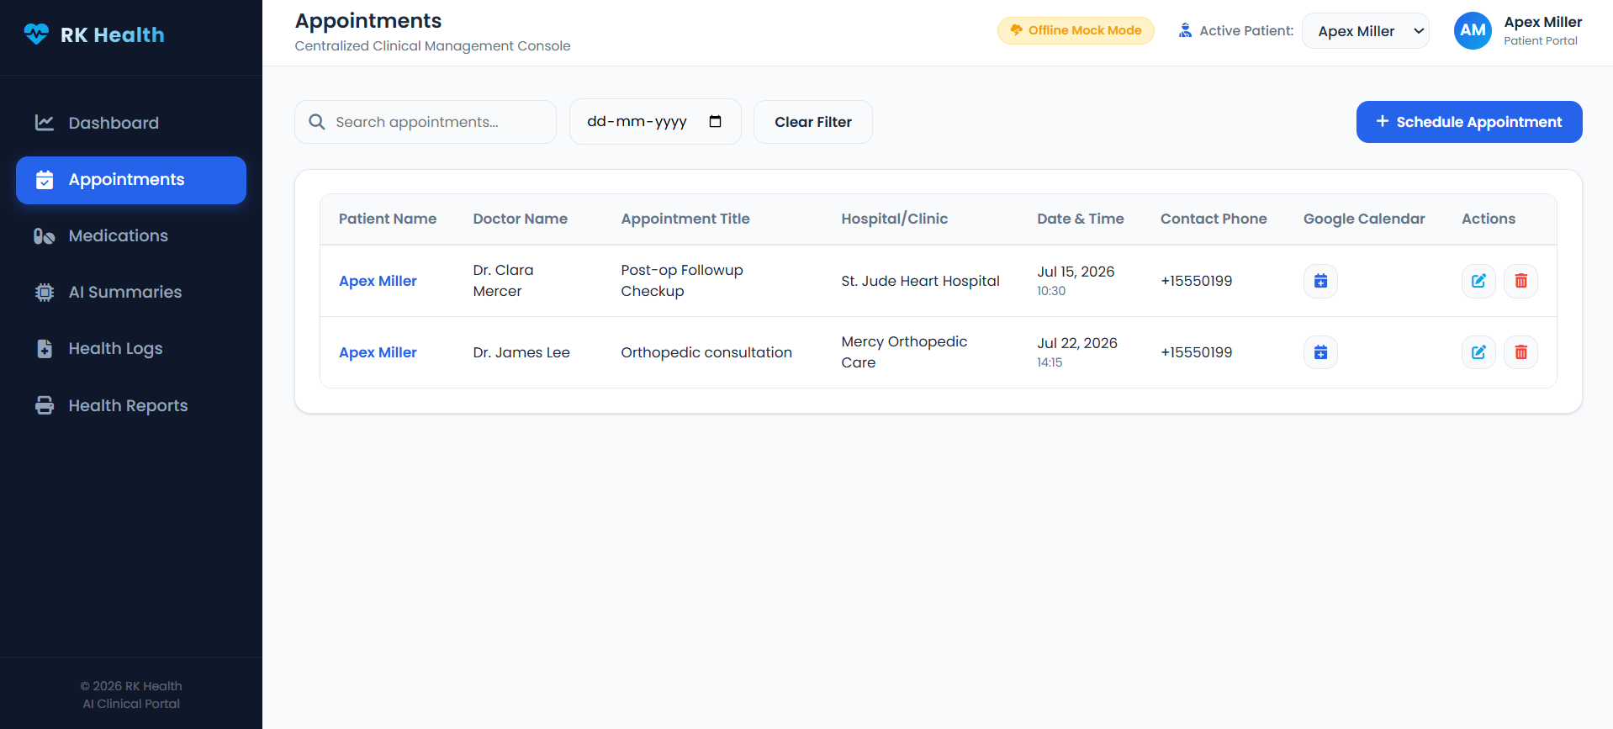

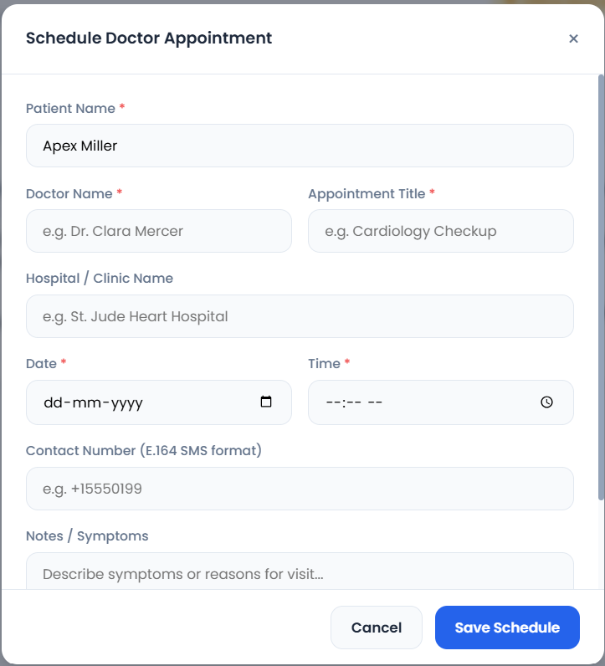

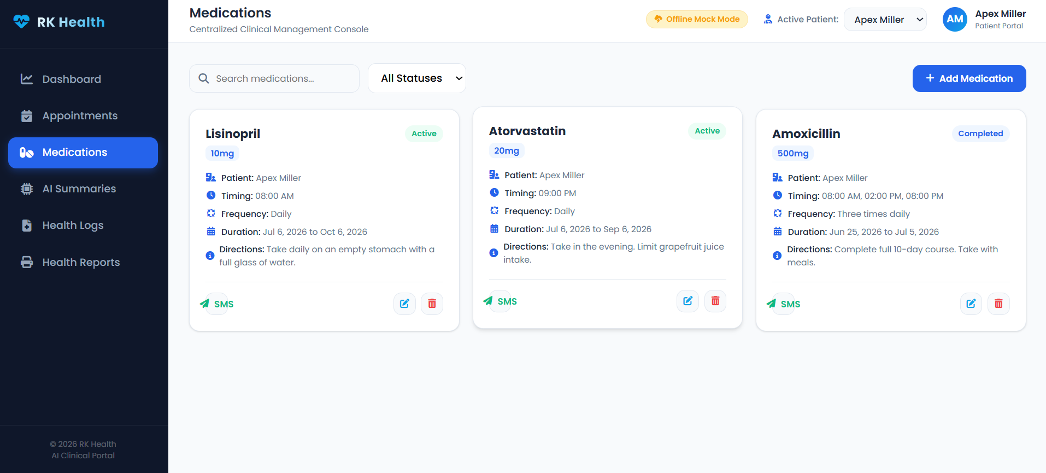
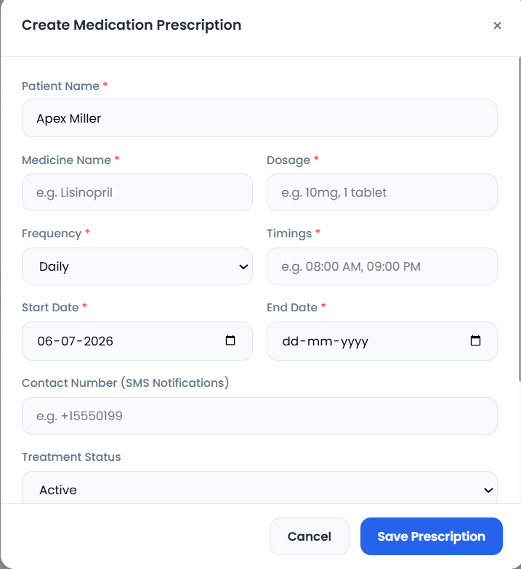

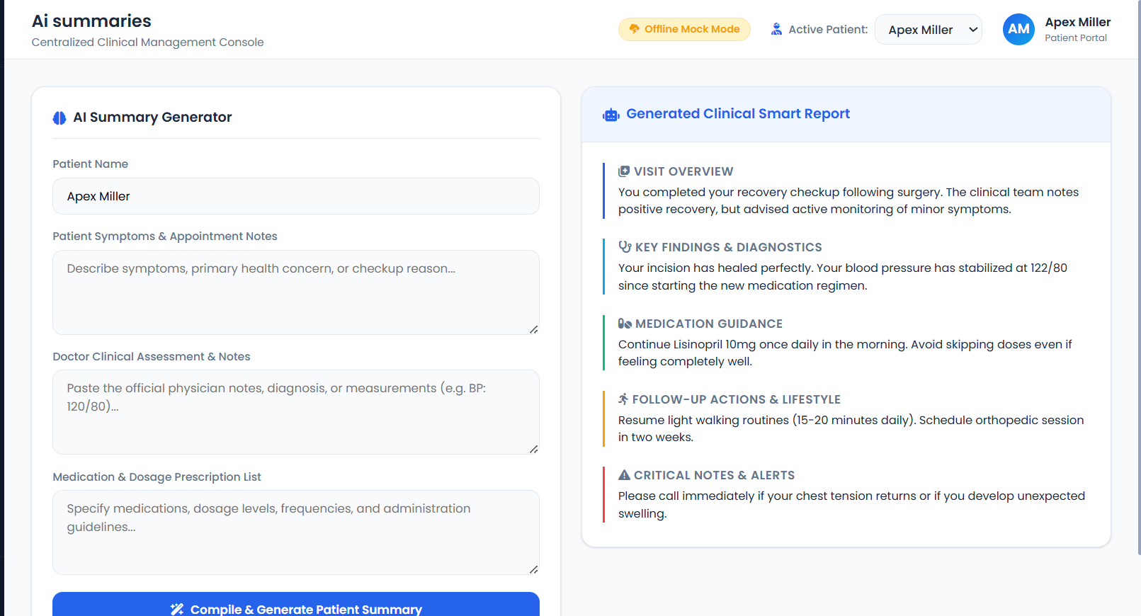

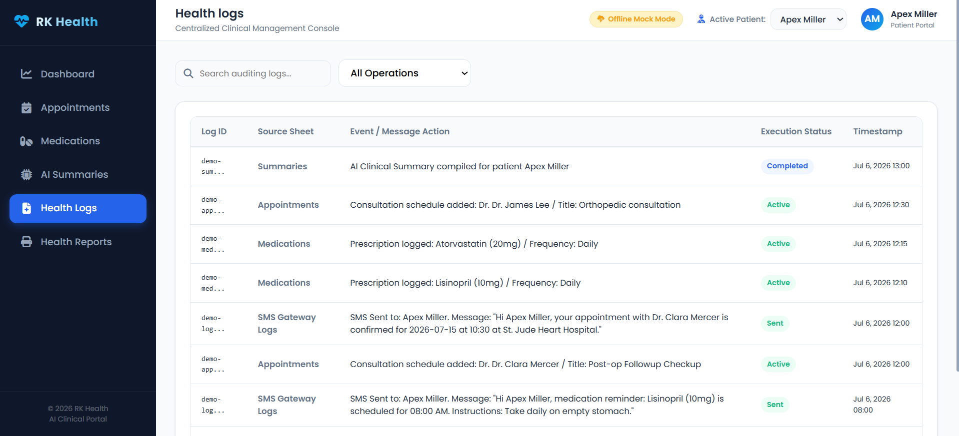

The demo of the app is available at:-

Code :

*** HappyCoding!! ***

